**Data structure**

A format for organizing storing, and processing data in a computer system

**Array**

* An array must store single data type only
* e.g scores = [5,7,9,11]
* scores = (5,7,9,11)
* *Other languages: scores – array of int [ ]

**2 Dimensional arrays**

Representing grids in code

Nums =

(y axis = rows, x azis = cols // e.g. cols 0 row 0 = 3

|  |  |  |
| --- | --- | --- |
| 3 | 5 | 8 |
| 1 | 2 | 5 |
| 3 | 3 | 3 |

* To reference value/ Cells in a grid, the following notation is used:

Nums[rows, cols] == result

Nums[0, 2] == 8

* Nums =[[3, 58], [1, 25], [3, 3, 3]

Nums [0, 1] == 5

Nums [2, 0] == 3

**To display an entire row**

**See VS code for notes**

* Record (tuple)
* Dictionary – key: Value pairs
* Reading from CSV text file

Dictionary

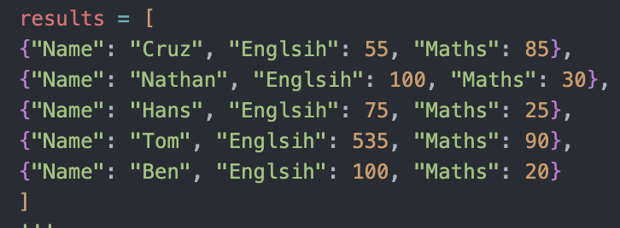

Tuples

